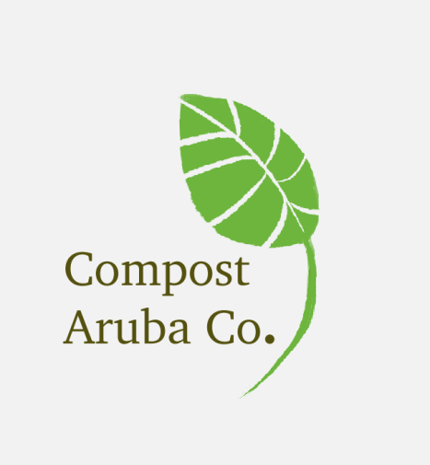

**GO ORGANIC AND THE GREEN WILL FOLLOW**

By: Ian Flanegien, Yaella Lopez, Nyasha Underwood, Kimberly Balcera, Jo-Anne Noguera, and Zia Habibe

Topic: Business Pitch

Lecturers: Christie Mettes and Tony Sevold

Course: Environmental Science

Date: 26th November 2017

# **Executive Summary**

Welcome to Compost Aruba Co! Our company was built to combat waste and make Aruba greener. In the following pages you will read about our ideas and ways in which we think we can capture the essence of efficient waste management focusing on the ‘Reduction’ of organic matter on our little island. In the following pages you will read on the way in which we will build our company. First of all, you will read about whom we will target and why we target them. Furthermore, you will read about our value proposition as in how will we create a value proposition for our company such as discounting. As you continue to read you will encounter how we plan on building customer relationships, what can be composted, the materials we would need, how we plan on creating business and what value we plan to propose to the customer. Lastly you will read about our revenue streams, our cost-structure and our key partnerships. In the following pages to come you will encounter information from the textbook and other sites that were used to create this phenomenal company. Enjoy!

**Content**

Executive Summary 2

Introduction 4

How to get value propositions (channels) 6

How to build Customer Relationship (Maintaining) 7

What organic materials can be used for composting (from the kitchen) 8

Machines and other necessary equipment (Key Resources) 9

What are our key activities 10

What Value do we bring to the customer (Value Proposition) 11

What are our Revenue streams 13

How we price our product (cost-structure) 14

Who we Partner with 15

Conclusion 16

References 17

Illustrations 18

# Introduction

Compost Aruba Co. was an idea created by our group member Nyasha Underwood and it sparked a lot of ideas throughout the group. According to our book composting is a great way to recycle valuable organic matter. Organic waste makes up 66% of all waste Fig 2. By composting we are breaking down the organic matter under aerobic conditions which makes nutritious soil, slows erosion, increases yield and retains water. We wanted a business that could help Aruba’s past, present, and future. We’ve learned that in nature, one species’ waste is another’s food, so that nothing is wasted. We need an ecological economy that recycles materials and uses energy efficiently. By picking up the food waste in most parts of the island we can help reduce waste by a big margin. We want it to be as eco-friendly as possible so we don’t leave behind a big carbon footprint. An essential part of our business is not only creating compost from food waste, but to also use that compost for the good of the island; spark inspiration in the inhabitants so that the people can plant more trees and flowers around the island which will help our nature, our air quality, natural resources, even planting fruits in vegetables which can encourage the locals to eat more healthy and organic food. So many benefits started popping up like a domino effect: Composting helps the island, it helps the people, helps the planet. We can also sell our compost internationally and by doing that, get the word out on how Aruba is becoming more eco-friendly so people with the same mind-set could also come to the island. Who to target (segment)

With our company, it is very important to target those who produce organic waste, so we can use that waste to fuel the production of composting. Luckily, most of the largest businesses on our island produce organic waste, e.g. hotels, restaurants, supermarkets. Not only do we take their waste to compost, but we can sell our products to these businesses because they take pride in their garden maintenance to attract the tourism industry.

For instance, targeting hotels or resorts is super beneficial for our company since they always have big beautiful gardens that they want to create or maintain. Our product would be useful if the hotels or resorts decide to expand their gardens or for new up and coming hotels. Since they always have big properties, if they decide to grow their own garden with different kinds of flowers, trees and grass, a lot of fertilizer would be needed. This is where we come in. The same counts for some outdoor restaurants.

Other than targeting businesses, one of the most important targets is the host community itself. Our community is very interested in planting. Every home has a few plants such as fever grass, palm trees, coconut trees, kenepa and mango trees, aloe and beautiful flower plants. To maintain these plants our community purchases fertilizer from the garden markets and supermarkets. By also targeting eco-friendly customers, it is a guarantee that they would like to buy and to donate to us because they care about the environment and would try their best to sustain it. Fertilizers are useful for planting at home, but they are also useful for recreational parks such as Wilhelmina Park which is filled with trees and meters of green grass.

Other than targeting businesses to take their waste, we also have to sell our product. Either we can sell our products directly to, for example, gardeners, or we can have distributors who resell our product e.g. supermarkets (Ling & Sons),and gardening companies (Flora Market).

# How to get value propositions (channels)

Value proposition would be received by giving value to our customers. We would do that by occasionally offering discounts on our products such as our fertilizer or composting services. This can influence first time buyers to try our product because of our discount offers. Once they tested our product and like it this could lead to them being a long-term customer and spreading positive word of mouth.

We would also offer bundling packages of our products along with 2 for 1 promotion. With this we create a bundle mix where all products give satisfaction to the customer and are also cheaper bundled together compared to when they are bought separately. A product bundle is convenient for the customer since they can buy everything they need in one go.

Punctuality is essential when it comes to making our product. We will make sure to make our product for the customer's needs or to have it in stock for the supermarkets as soon as possible. Knowing that the businesses and people who do give in their waste to us will get a small commission will surely help in having enough waste to produce without being short.

Long- term customers would receive a loyalty cards which let them get special deals or discounts on our services. We reduce the total cost of trash collection Part of our profit would go to a good cause such as charity as well. Giving back to our community aids in becoming more socially aware to help those in need.

Our company could be considered a green business. Green business works because consumers are becoming aware of ecological consequences of their purchases. Increasing interest in environmental and social sustainability has caused an explosive growth of green products.

# How to build Customer Relationship (Maintaining)

A customer relationship is important for any business, but maintaining these loyal customers is also a part of making profit. By maintaining customer relationships, we could give advantages for these loyal customers. How they will benefit is, for example, if you give us your organic trash, you will be able to get the product at a cheaper price.

Furthermore, a method we would use is PR (public relations). This means that by having a very good customer service policy, our best customers will spread word of mouth to other people to raise awareness about our company. Also if our company gets certified with an Eco-friendly label, customers can see that we are being eco-friendly and would participate more.

We will keep our customers feedback in mind, and give presentations to keep them updated about our product or business and give them a voice because at Compost Aruba Co.

Lastly, an effective way of maintaining customers is by using stamp cards. These give customers the possibility to get a reward with an amount of purchase of our products. For example, get one stamp with each purchase of our product. Customers would like knowing they get our product for free after an amount of purchases.

# What organic materials can be used for composting (from the kitchen)

Include

➢ Fruit trimmings & Vegetable trimmings

➢ Cereals

➢ (Stale) Breads and pita

➢ Old wine

➢ Dry cat or dog food

➢ Apple cores

➢ Old herbs and spices

➢ Banana peels

➢ Stale crackers

➢ Old oats

➢ Corn cobs

➢ Nut shells

➢ Chopped avocado, mango, plum and peach pits

➢ Toothpicks, wine corks

➢ Egg cartons

➢ Egg shells (crushed is better)

➢ Coffee grounds and teabags

➢ Carrot peelings

➢ Melon rinds

➢ Cardboard boxes

➢ Burnt or un-popped popcorn kernels

➢ Kitchen towel rolls (e.g. Bounty, make sure it’s shredded)

➢ Pizza crusts

➢ Spoiled non-dairy milk (coconut/almond/rice/soy milk)

➢ Old jams, preserves or jellies

➢ Old chopped sunflower seeds

➢ Old chopped sesame seeds

➢ Paper muffin/cupcake cups

And many more everyday household kitchen items can be used for composting!

Avoid

➢ Raspberry & blackberry brambles

➢ Items containing old ketchup, soy sauce, relish

➢ Walnut shells

➢ Paper plates with a waxy coating

Exclude

➢ Meat

➢ Dairy (milk, butter, cheese)

➢ Fish

➢ Fats

➢ Bones

➢ Salad dressing

# Machines and other necessary equipment (Key Resources)

The machines that we need are organic compost machines, which will use the in-vessel composting. These systems can consist of plastic or metal tanks or concrete bunkers, in which the flow of air and the temperature can be controlled using the principles of ‘bioreactor’. The air circulation is usually measured via tubes that allow the fresh air to be injected under pressure, with the exhaust being extracted through a bio-filter, with temperature and moisture conditions monitored using probes in the mass to allow maintenance of optimum aerobic decomposition conditions. The machine would cost around $5500-$8000, which is fairly affordable in the line of work we will be doing. The machine would be able to compost 250 kg worth of organic waste/material.

Solar composting can make the process easier and faster by using the sun's energy to increase temperature and regulate moisture and airflow. But since this method is expensive to start we started small with electricity and as the company grows we improve our brand and use solar energy.

Solar power is the driving force behind the Extended Aerated Static Piles (eASP) prototype in Joaquin Valley. The eASP uses solar energy instead of diesel fuel to aerate composted materials. It's part of an effort to reduce emissions, as well as energy, land, water usage, and the production of volatile organic compounds (VOCs). How silicon in solar cells work: Light is converted into electricity by the photovoltaic effect. When light is incident to the cell, the absorbed energy excites bound electrons. This allows them to jump their atomic bonds and become free. The free electrons travel through the material, and the resulting current is harnessed when conductors are attached to either side of the cell. Because there are no moving parts, including turbines, maintenance fees are lower and there is zero fuel use.

We will need trucks to deliver/provide the fertilizers that we made from our composted waste/materials, to the business/partners that our company works with. We will also need a large enough area for our work facility where we can properly separate and work with the waste that we received from our partners/companies that we work with.

For physical labor we will need more or less a handful of employees to help our company run more smoothly. We will need electricity, which will be provided to us by solar power, because our company strives to be sustainable and eco-friendly.

# What are our key activities

In order for our company to perform well, we would need to develop strong relationships with waste management companies and our customers. Waste management companies can help us by providing us with food waste that goes into their company. If we have a good relationship with them, we will need fewer trucks to pick up the food waste from each area because the waste management companies will send it directly to us.

It is certain that a company cannot perform well if it's not known. By promoting and advertising we can make a "buzz" and let people know about our product. Also, by giving presentations or workshops both at schools and to the public, we can educate people to create awareness.

By hosting or sponsoring events, we can capture the attention of both eco-friendly people but also those who are not so eco-friendly, focusing on persuading people to see the importance of being environmentally conscious is a key component in fighting the big battle. With fundraising, we can collect funds that will help us better our services and develop more ways we can use food waste into something beneficial for everyone. Having a strong customer relationship will help us know what they value in our product and how else we can improve it.

# What Value do we bring to the customer (Value Proposition)

We provide value by giving a good image, since it is a composting business it is environmentally friendly which is of great importance these days. Because of this, we provide another waste alternative to our customer. This helps them be able to contribute to Aruba becoming an environmentally conscious island since we put the waste they dispose of to good use. In Fig 3, we see the amount of organic waste that can be reused. Because of this, no trash will end up in our oceans.

Furthermore, we create value by choosing a great method for recycling. Composting does not contribute to air pollution as other aspects. As for how composting relates to air quality "VOC (Volatile Organic Compounds) emissions from composting piles are dominated by small, light alcohols such as wood alcohol, isopropyl, and ethanol. None of these compounds are strong ozone-forming agents when part of a diverse atmosphere. Composting emissions do contain small amounts of stronger ozone-forming agents, such as terpenes and aldehydes. The overall ozone formation potential of composting emissions is quite low, about one-third as potent as a typical urban VOC mix.” http://www.calrecycle.ca.gov/organics/air/

Our company is looking to incorporate some laws that are being practiced in the United States, even though they’re not laws here, to help guide our company in staying on the right track of being environmentally conscious. For example: The Clean Water Act. Environmental policies are rules that are established that protect not only the environment and natural resources, but the public health as well. We will not be using any harmful chemicals that could pollute our waters and we are going to help clean up our waters by cleaning up trash in the surface waters around the island. We are also going to help protect our wild life, especially the ones endangered (The Endangered Species Act.) Most of our animals become endangered due to invasive species that have no natural predators like the boa, but also deforestation, and with our help rebuild in new homes for these animals who have had theirs taken away or places that are no longer safe. Shed light on the importance of these issues to the government and make them law would be a big goal achieved, because getting more businesses to care about the environment and the overall health of the island is when change will actually happen.

Our products would not be imported which means the costs to the environment for making our products would be relatively low; our customers would get a good price for our services such as composting and/or our fertilizers. Fertilizers made out of compost have more nutrients compared to the ones that are commercially made. We will sell these to supermarkets all around Aruba so it can be easily accessible.

As for how composting relates to water pollution, is that a lot of the pollutants in water comes from landfills. Our landfill is located near the sea, so every time it rains here, all of the filthy rain water goes into our sea, thereby polluting our clean water. This in turn can lead to the planktons being contaminated, and when the fish eat the contaminated planktons they will also become contaminated, making the fish we eat unhealthy. By composting we can reduce the amount of waste that will go to the dump. Thereby reducing our landfill and also keeping our waters clean, making it better for the underwater ecosystem and for us on the island.

We also promote planting with our healthy fertilizer, which can inspire locals to start planting their own fruits and vegetables. By encouraging locals to plant more it also helps reduce pollution since plants reduce the amount of carbon dioxide in the air.

In Fig. 1, we can see how our company will benefit the island. Such a large percentage of trash goes to the landfill that can be composted. Our company helps the environment by providing another means of trash reduction.

# What are our Revenue streams

In order for us to start our business we need capital, that's where investors play an important role. Investors will help us financially. With their help we will be able to cover the cost of for example, buying the machine we need to use to process the food waste, trucks to pick up food waste, the monthly salary of our employees etc. Of course, the benefit that our future investors will get is the return on investment.

Selling the fertilizers that we make will give us a return on revenue. The price of the fertilizer will depend on each size of the packet or depending on how much square meters are needed. One of our pricing tactics would be, for example: bundles which will attract customers to buy more. By fundraising (as previously mentioned), we can raise awareness on the benefits of composting and therefore attracting more customers to buy our products so we can continue to have a big return on revenue.

Another way our company can get income is through subscription fee. Our loyal customers can pay a monthly subscription fee for us to supply them the monthly amount of fertilizers they need. That is why it is important for us to maintain our quality or even make it better to retain loyal customers and have a competitive advantage. With this competitive advantage we will be guaranteed to have a high return on revenue compared to our rivals. Overall, we must pay close attention to how the money we earn will pay for everything that is required to make compost out of what was once waste and bring those products to the market.

# How we price our product (cost-structure)

Our company will be the first of its kind in Aruba. It reigns supreme in quality fertilizer and every possible measure will be taken to make this company as environmentally friendly as possible. Our costs will also be a result of our materials, activities, and partnerships. We should not exclude our loans and other expenses such as rent, electricity and our loans.

Our company is value-driven. We produce and deliver exceptional product that consumers will be willing to spend an extra few florins on. The quality of our product shows in the health of the plants in very plant pot and landscape in every home business and company.

As our output increases our cost will diminish because most of our costs come from our fixed cost of our materials and key resources. As the company progresses our marginal costs will decrease as well as our average cost per unit. Our product will not be priced on the high end but it will also not be priced as the cheapest product on the market because we make and supply quality which would be worth every cent!

To start we would need $75220 dollars see fig 4. Our monthly fees would be $13225 see fig 7.

We operate 6 days a week 8 hours a day but our machine operates 5 days 20 hours a day. It makes 250Kg every time which makes 5000Kg per month. We decided to sell 400 ten kg boxes and 200 five kg boxes. If we divide this so that our marginal cost equals marginal revenue we would be selling $26.45 for a 10kg box and $13.23 for a 5kg box. We would like to make 30% profit so as calculated we would be making $3967.5 because 30% of our monthly fee is $3967.5.

This means our products will be sold at $17.20 (Afl 30.10) for a 5 Kg and $34.40 (Afl 60.20) for a 10kg box. Because monthly fee plus our 30% divided by our 400 10kg box and 200 5 kg box gives us these prices which places us around the middle of the price range of our competitors.

# Who we Partner with

As a composting company, it’s important for us to target the right people. For instance, targeting hotels would be super beneficial for us since hotels are one of the biggest waste producers on the island, including organic waste. Not only do we get the organic waste from the rooms where the tourists stay in, but also from the staff members, bars, casino’s, restaurants located in the hotel themselves, and of course from the kitchen where the room service meals are made. Since hotels produce such a huge amount of waste, including organic waste, adding all the hotels on the island would produce an even greater amount of waste for our company to collect. Restaurants and schools like EPI or any kind of business that serves food are also key targets for our company, since their businesses revolves around organic matter/waste. Businesses our company would target include e.g. bed & breakfasts, fast-food chains like Wendy’s and Subway, since they produce a lot of organic food waste daily.

Also, our company would like to have a partnership with the government and the private sector. The government can play a huge part in the making of laws that help encourage the host community and local businesses to compost. The government can come up with taxing laws on certain/specific goods. The government can provide the host community with a small bin so that they can start collecting and separating their organic waste, and to later bring it to our company so that we can make it into compost. By encouraging the host community and local businesses to start collecting waste, it can greatly help reduce our landfill waste and help Aruba to become a more eco-friendly and sustainable island. The private sector would be a good partner since more people are now supporting companies that are now more green and eco-friendly and are willing to make a difference in helping out the environment.

# Conclusion

To conclude our company is a strong company that will put Aruba on the map. Our company targets all of Aruba that is involved with gardening in one way or the other from hotels and supermarkets to the community. Using channels such as bundling and discounts we create the value proposition. We plan on maintaining customer relationships though PR, promotions and presentations. From a facility to trucks we have all of our materials covered to ensure success. Furthermore, key activities such as ecofriendly events and selling our product are at the top of our list. We create value by being ecofriendly, promoting planting and creating a more greener Aruba. Not to exclude our revenue streams and cost-structure shows the best ways we can create profit and finance our product. Lastly, we partner with companies, the government and other sectors to ensure the well-being of our island and prosper of the community and our company.

# References

# Cnningham, M. A., & Cunningham, W. P. (2013). *Principles of Environmental Science 7th Edition.*

Google.com

<http://gsvc.org/wp-content/uploads/2016/10/Cost-Structure_Business-Model-Generation.pdf>

<http://www.calrecycle.ca.gov/organics/air/>

<https://en.wikipedia.org/wiki/In-vessel_composting>

<http://www.zerowastescotland.org.uk/content/what-vessel-composting-0>

<https://www3.epa.gov/npdes/pubs/invessel.pdf>

<https://www.alibaba.com/premium/composting_machine.html?src=sem_ggl&cmpgn=897160725&adgrp=44662956437&fditm=&tgt=kwd-301219641302&locintrst=&locphyscl=2533&mtchtyp=b&ntwrk=g&device=c&dvcmdl=&creative=210178432456&plcmnt=&plcmntcat=&p1=&p2=&aceid=&position=1t1&gclid=CjwKCAiAxuTQBRBmEiwAAkFF1vLyVnm3_EPK3KeB9tO_RQs1Ki5DVRetiR-tNMgcTRAD-dTwFOdD-hoC0ncQAvD_BwE>

<https://www.smallfootprintfamily.com/100-things-you-can-compost>

<http://compostguide.com/compost-materials/>

<https://www.wastewiseproductsinc.com/blog/sustainability/recycling-innovations-solar-powered-composting/>

<https://www.azom.com/article.aspx?ArticleID=12014>

# Illustrations

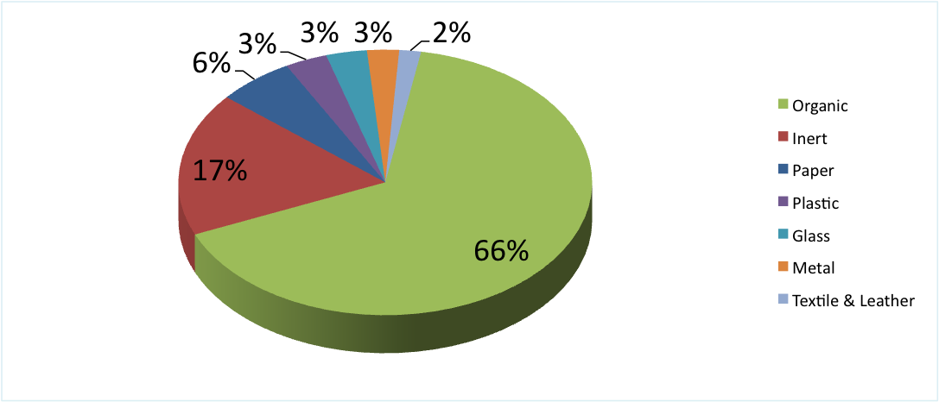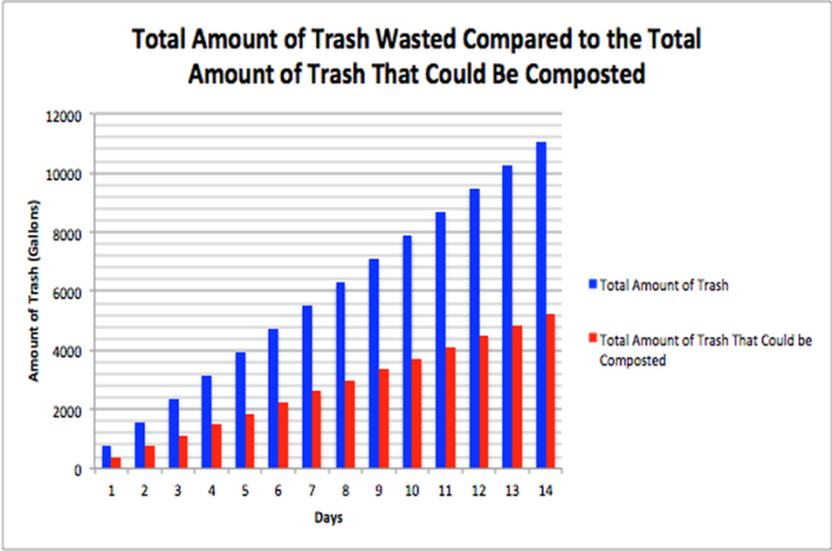

Fig 2

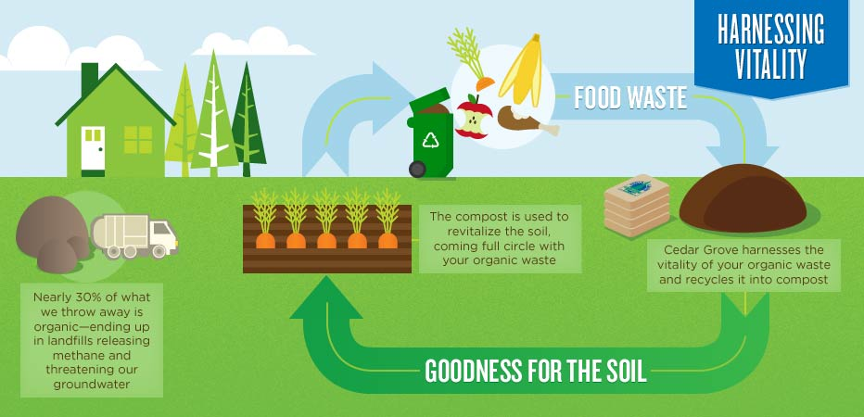Fig 1.

Fig 3.

|  |  |
| --- | --- |
| Machine | $5500-8000 (we went with 8) |
| Facility or 6 months | $2500*6=$15000 |
| Water and light for 3 months | $1500 |
| 4 employees and 1manager for 6 months | $7020*6=42120 fig 5 and 6 |
| 1 second hand truck for delivery | $6000 |
| Pagaking Compostable boxes 400 10kg 200 5kg | $125 |
| Commission and other expenses | $2500 |

Fig 4.

Fig5+6: note* this numbers are in florins and were converted to dollars. $=Afl. The $ is supposed to be Afl.

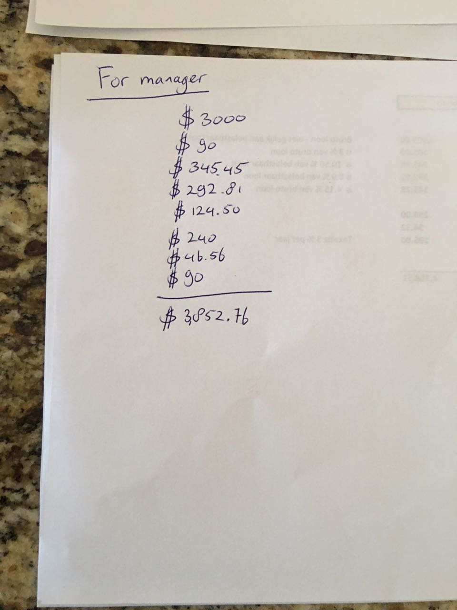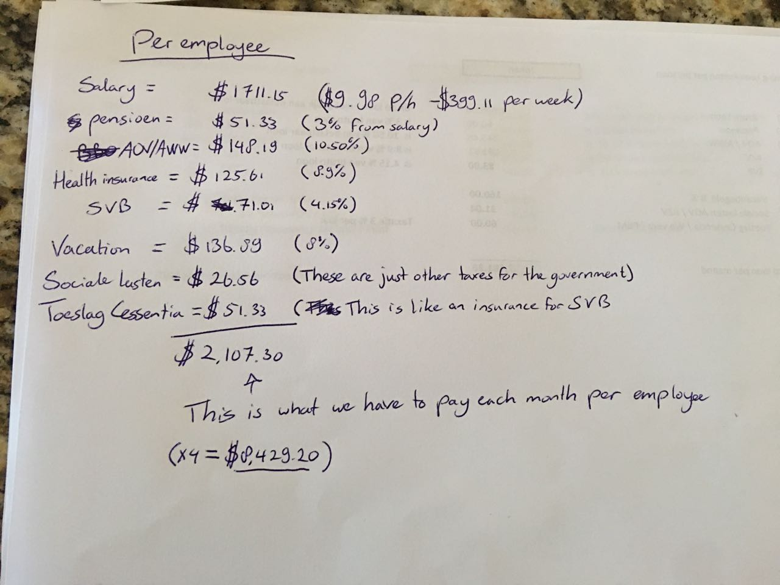Fig 5 and 6

|  |  |
| --- | --- |
| Rent | $2500 |
| Water and light | $500 |
| Monthly salary for employees | $7020 |
| Gas or the truck per month | $400 |
| Boxes | $125 |
| Commission and other expenses | $2500 |

Fig 7